Computer Networks Lab Report
Submitted By
V. JEEVAN
RA2411030050037
Under the guidance of
Dr. Mallika
(Assistant Professor, School of Computing)
in partial fulfilment for the award of the degree
of
BACHELOR OF TECHNOLOGY
in
DEPARTMENT OF COMPUTER SCIENCE AND ENGINEERING WITH CYBER SECURITY
Of
FACULTY OF ENGINEERING AND TECHNOLOGY

SRM INSTITUTE OF SCIENCE AND TECHNOLOGY,
TIRUCHIRAPPALLI
Academic Year: 2026–2027
Date: 23 October 2026

Computer Networks Lab – Experiment 1
Experiment Title
Introduction to Packet Tracer, Peer-to-Peer Communication, Study of Cables and Their Color Codes.
Aim
To get familiar with the Cisco Packet Tracer simulator, to set up a simple network of two PCs connected through a switch and verify communication between them using static IP addresses, and to study Ethernet cables and their T-568A/T-568B colour codes.
Software Requirements
• Cisco Packet Tracer (network simulation software)
• Windows PC to run the simulator (project saved as lab 1.pkt)
Brief Theory
Packet Tracer: a simulation tool used to design, configure and test networks using virtual devices such as PCs, switches and routers, without physical hardware.
Peer-to-peer communication: two hosts exchange data directly with each other as equals. Here, PC0 and PC1 are linked through a switch and, being in the same network (192.168.1.0/24), can communicate without a router. The ping command (ICMP echo request/reply) is used to test reachability.
Cables and colour codes: Ethernet UTP cables contain four twisted pairs (eight wires) terminated in an RJ-45 connector using either the T-568A or T-568B standard. A straight-through cable uses the same standard at both ends and connects unlike devices (e.g., PC to switch). A crossover cable uses T-568A at one end and T-568B at the other and connects like devices (e.g., PC to PC).
T-568A and T-568B Colour Codes
Pin | T-568A | T-568B
1 | White / Green | White / Orange
2 | Green | Orange
3 | White / Orange | White / Green
4 | Blue | Blue
5 | White / Blue | White / Blue
6 | Orange | Green
7 | White / Brown | White / Brown
8 | Brown | Brown
Step-by-Step Procedure
1. Open Cisco Packet Tracer and use the Logical workspace to build the network.
2. Place two PCs (PC-PT), named PC0 and PC1, and one 2960-24TT switch (Switch0) on the workspace (Fig. 1).
3. Select Copper Straight-Through from the Connections palette and connect PC0 to Switch0 and PC1 to Switch0. The link indicators turn green when the links are active (Fig. 2).
4. On PC0, open Desktop > IP Configuration, select Static and enter 192.168.1.1 with subnet mask 255.255.255.0 (Fig. 3).
5. On PC1, enter 192.168.1.2 with subnet mask 255.255.255.0 (Fig. 4).
6. On PC0, open Desktop > Command Prompt and run ping 192.168.1.2 to test connectivity with PC1 (Fig. 5).
7. Study the T-568A and T-568B colour codes of Ethernet cables.
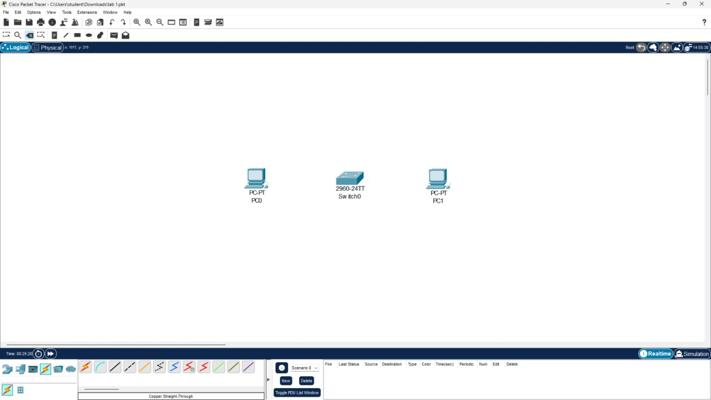
Fig. 1: PC0, PC1 and 2960-24TT Switch0 placed in the Logical workspace (no links yet).
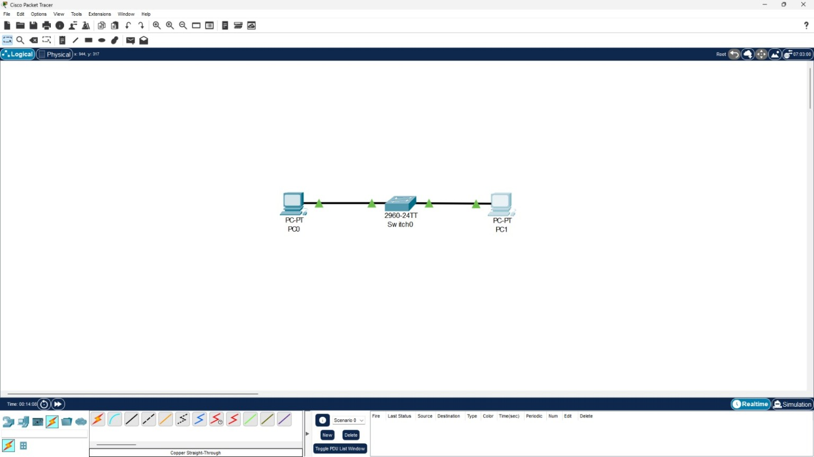
Fig. 2: PC0 and PC1 connected to Switch0 using copper straight-through cables; link indicators are green.
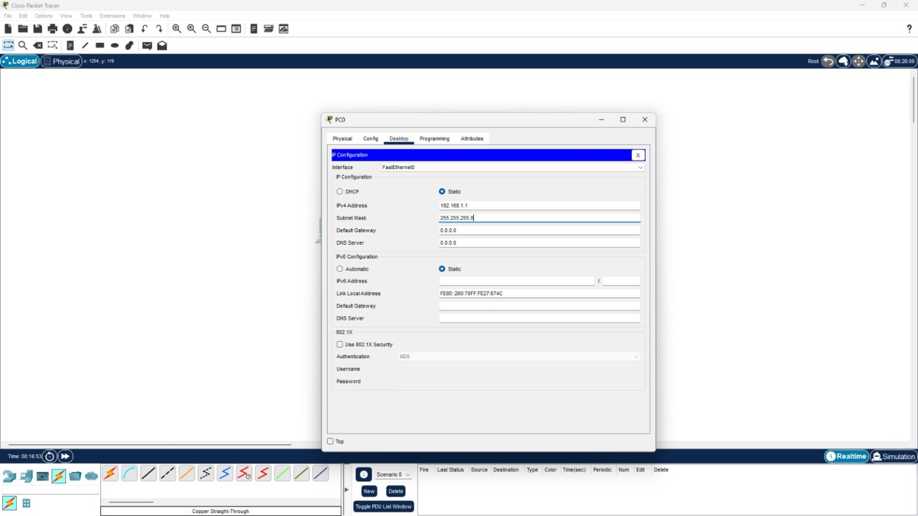
Fig. 3: IP Configuration of PC0 (192.168.1.1 / 255.255.255.0).
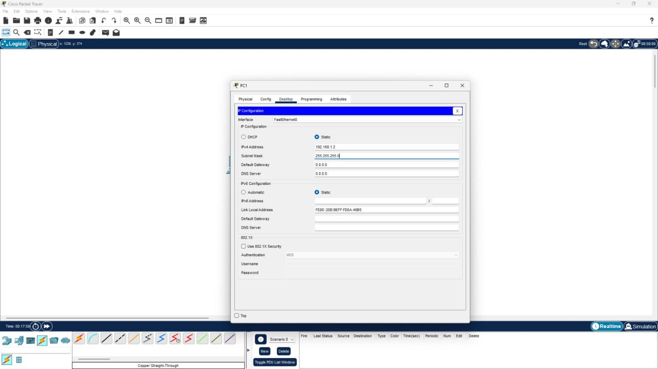
Fig. 4: IP Configuration of PC1 (192.168.1.2 / 255.255.255.0).
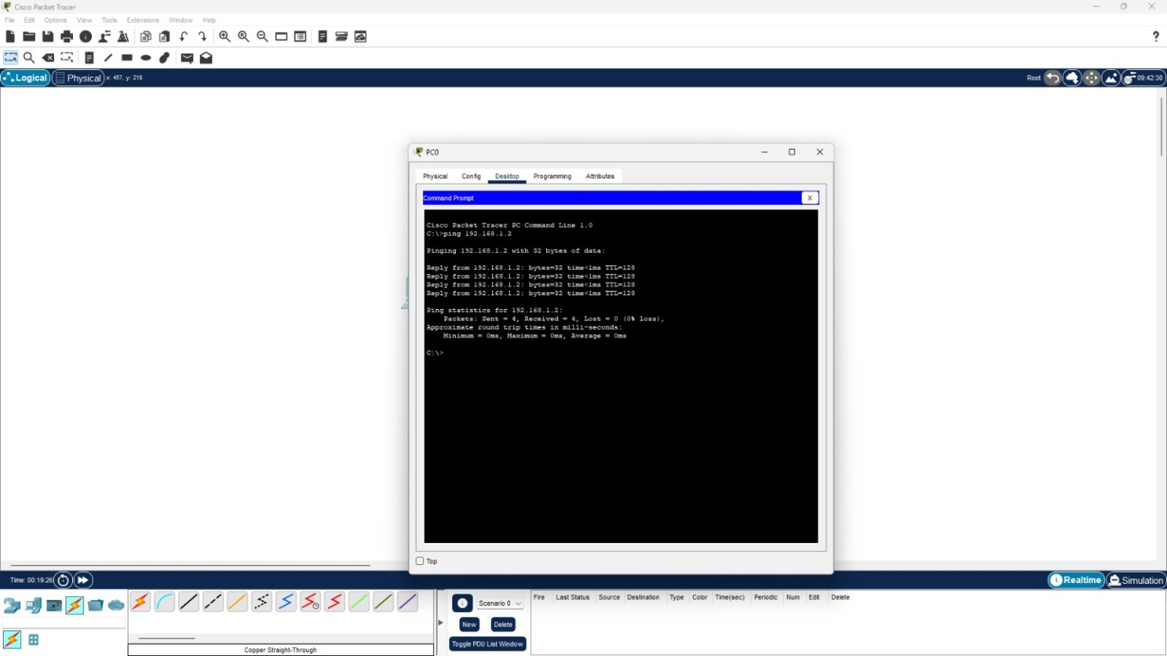
Fig. 5: Successful ping from PC0 to PC1 (192.168.1.2) with 0% packet loss.
IP Address Configuration
Device | Interface | IPv4 Address | Subnet Mask | Default Gateway
PC0 | FastEthernet0 | 192.168.1.1 | 255.255.255.0 | 0.0.0.0
PC1 | FastEthernet0 | 192.168.1.2 | 255.255.255.0 | 0.0.0.0
Both PCs use static addressing (DHCP not selected). The default gateway and DNS server were left at 0.0.0.0, since both PCs are in the same network and no router is used.
Testing and Verification
Connectivity was tested from PC0 using ping 192.168.1.2. Four replies were received from 192.168.1.2; packets sent = 4, received = 4, lost = 0 (0% loss).
Study of Cables and Their Color Codes
The pin-wise colour arrangement of the T-568A and T-568B standards was studied. In Packet Tracer, the Copper Straight-Through cable was used for both PC-to-switch links. No physical cable crimping evidence was included in the supplied screenshots.
Result
A network of two PCs (PC0 – 192.168.1.1 and PC1 – 192.168.1.2) connected through a 2960-24TT switch with copper straight-through cables was created in Packet Tracer. Ping from PC0 to PC1 returned 4 of 4 replies with 0% loss, confirming successful communication. The T-568A and T-568B colour codes were studied.
Conclusion
The experiment introduced the Packet Tracer interface and the steps of building a simple network, assigning static IP addresses and verifying connectivity with ping. Hosts in the same subnet communicate without a router, and a straight-through cable is used to connect a PC to a switch.

